THE MAGIC OF THE FA VASE
The FA Vase is the best domestic tournament we have. Perhaps a slightly controversial statement but there's few other tournaments where there is such an open field of teams that are competing at similar levels both in terms of the resources and finances.
The incentive of a day out at Wembley is a great incentive to all sides and in recent years, with a decline in the domination of the teams from the Northern League, it has provided us with a hatful of new names of clubs hoping to use the competition as a stepping stone to greater things.
In the last six competitions, eleven of the twelve finalists have since been promoted to Step 4 or above, including last season's finalists Warrington Rylands and Binfield. Despite the pressure of fixture pile ups, it seems that building a winning momentum on the way to Wembley aids rather than abets league form for clubs.
The Northern League sides have dominated the competition for many years, primarily due to the strength of the sides in that league who for many years rejected the chance to move up the pyramid. From 2009 to 2017, the competition was won by a Northern League side, with the only exception being in 2014 when West Auckland Town lost to Sholing.
However, it was the southern-based sides who had initial success after the tournament was launched back in 1974. The first winners were Hoddesdon Town, currently playing in the Essex Senior League before Billericay Town won three out of the next four tournaments. There's even been two current league sides who have played in the final at Wembley Stadium - Forest Green Rovers in 1982 and Fleetwood Town in 1985. In the near 50 year history of the competition, no side from Sussex has ever reached the final - Whitehawk came close back in 2010, losing to Wroxham in a two-legged semi-final.
Since 2017, with promotion mandatory from the Northern League to Step 4, three of the four winners have come from areas outside of the North East. This season only one side remains from what was the strongest league at Step 5 and 6 in the last 16 clubs underlining how times have changed.
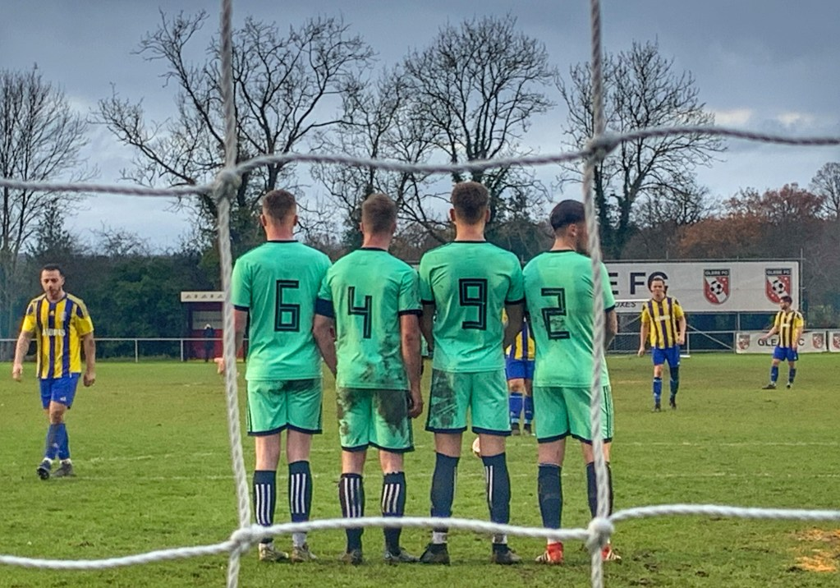
In financial terms, past performance is no guarantee to future success, but there's certainly one or two clubs that are still in the competition that could make an appearance at Steps 3 and 4 in the coming years although the last round saw some of the bigger teams make surprise exists including Saffron Walden Town, AFC Liverpool, Consett and Littlehampton Town. Our nearest side still in the competition is Tunbridge Wells, finalists back in 2013 when they lost to Spennymoor Town (who now play in the National League North), who beat Bridgewater Town on penalties.
This year’s final, on Sunday 22nd May will see Littlehampton Town play Newport Pagnell Town at Wembley. The Sussex side beat Loughborough Students 4-0 in their semi-final, played in front of a club record crowd of over 3,000 (the biggest non-league crowd in Sussex this season).

