RULES, RULES, RULES - THE 92 CLUB
The 92 is a genuine club - the 'most exclusive club' in football if you believe the website, which I do. It has rules, it has members who enforce the rules, it has a committee who create new rules and deep down most football fans want to be part of an exclusive club of football fans who have seen a match* at every one of the 92 Premier and Football League venues.
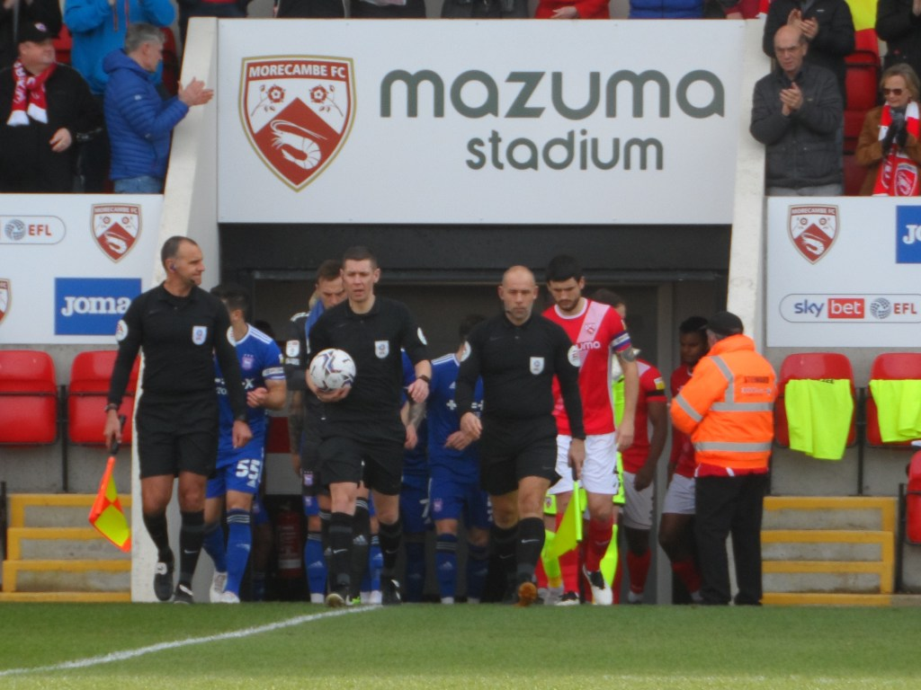
Before the days of the Internet the club operated under very strict rules. A ground could only be counted if you saw a competitive match - no friendlies allowed, unless they were international friendlies but only if England (or Wales) were playing. If a club dropped out of the league and returned, sorry but you had to revisit - which proved a nightmare for many when this fate fell on Carlisle United. But despite the rules, to qualify you simply had to provide a list (written on a photocopied sheet) of your qualifying games and you were in. A small membership fee, a pin badge and some optional cufflinks for £15.
I first qualified back in 1995, my final ground being Anfield watching Liverpool destroy West Ham. But in 1999 it all went to hell in a handcart as new grounds opened and promotion from the Conference began. All of a sudden I was missing 2, then 3 and 4 grounds. Fortunately the club had gone digital and with so many high profile games being scheduled the rules relaxed. A ICC cup game at Spurs new stadium versus Inter and AFC Wimbledon playing a Liverpool XI both counted in the new world but wouldn’t have in the old days despite both grounds being full.
At the start of this seasons I had two still to revisit - I’d been to Newport County when they played at Somerton Park and then the appalling International Stadium but I’d never seen football at Rodney Parade (rugby yes). A very wet night in September last years saw that one ticked off leaving just Morecambe. A work trip to Scotland gave me the opportunity of completing the 92, for the third time, although I would have to miss the guaranteed goal-fest at Corinthian-Casuals.
I’d been to Christie Park before, watching Luton Town in their season where they almost pulled off the miracle of the 30 point penalty. A perfectly good ground that was sold in a land deal and the club moved a mile south to a new build stadium. There’s been false dawns in terms of planned visits cancelled but here I was finally about to rejoin not only the 92 club but also become a member of the 116 (including the National League). There would be no fanfare, no presentation on the pitch and no champagne and that was no problem.
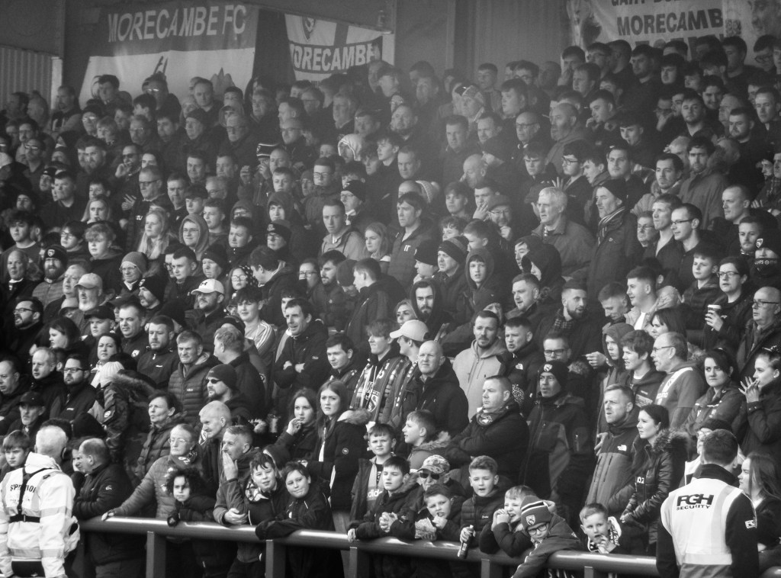
With no new stadiums on the horizon and no teams due to come up for at least a year who I hadn’t visited, I was safe in the knowledge I could rest on my laurels once again.
Some fans will only count a game if they get a programme or at least a team sheet. Others won’t count a ground unless they see a goal, or even in some cases, a goal at each end. There is a very strange group who need to touch the ball for a ground to count. For me, a picture of the game will do me fine. The 'new' rules are much less draconian and reflect the nature of football today.
We all have our war stories, of games that have been postponed or abandoned (neither of which counted in the old days), of food poisoning and officious stewards but I wouldn’t have changed anything along the way. For your reference, my first “tick” came back in 1974 at The Valley with Charlton Athletic beating Burnley 4-1.
But if a random person at a game comes up to me now and asks for “my number”, I can legitimately say once more “92”….at least that’s what I think they mean?

