KNOW YOUR STEPS - PROMOTION & RELEGATION RULES 21/22
Step 1 to 2
Dover Athletic are already relegated. Starting the season with a minus 12 points deduction, they are still in the negative with just one win all season. They will drop into National League South and are likely to be joined by Kings Lynn Town and Weymouth, who are nine points from safety. The former would likely go into the North division where they came from and Weymouth into the South with Dover Athletic.
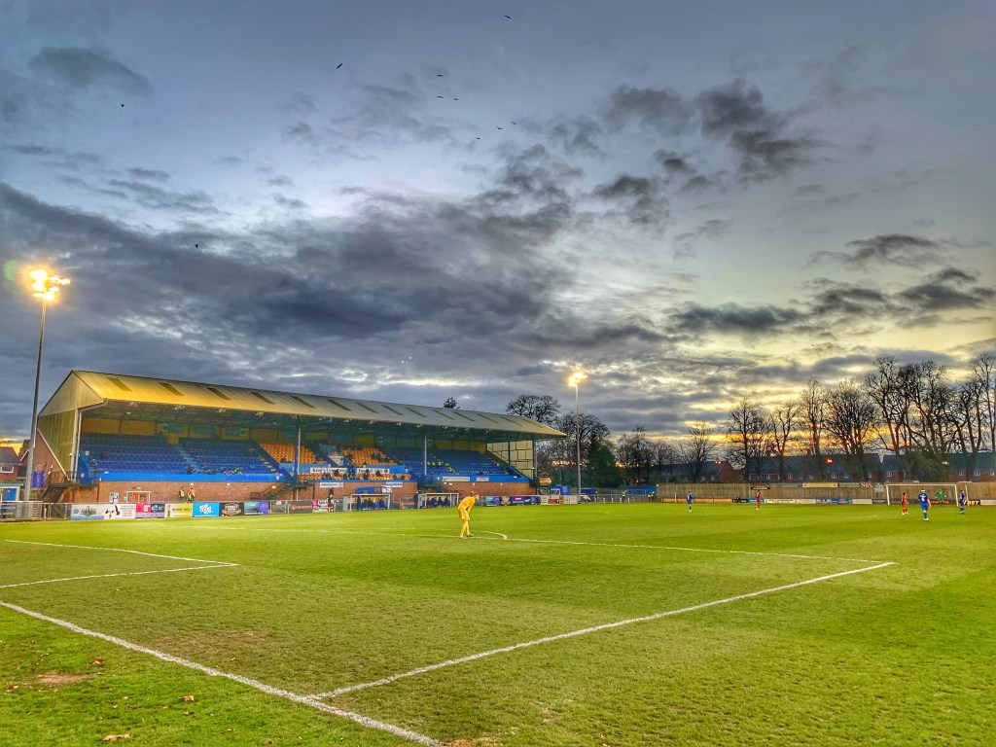
From Step 2, the champions (currently Maidstone United and Gateshead lead their respective divisions) and the two play-off winners will be promoted. In the National League, play-off places extend down to 7th place.
Step 2 to 3
Due to the National League running three teams short of their compliment of 24 sides in each division, rather than promoting more sides, they have naturally chosen to relegate less. So only one side from each of the National League North and South will be relegated to Step 3.
In the North that could be any one from five sides realistically - Guiseley are currently bottom but have games in hand, Farsley Celtic, AFC Telford United, Blyth Spartans and surprisingly, last season's front runners, Gloucester City.
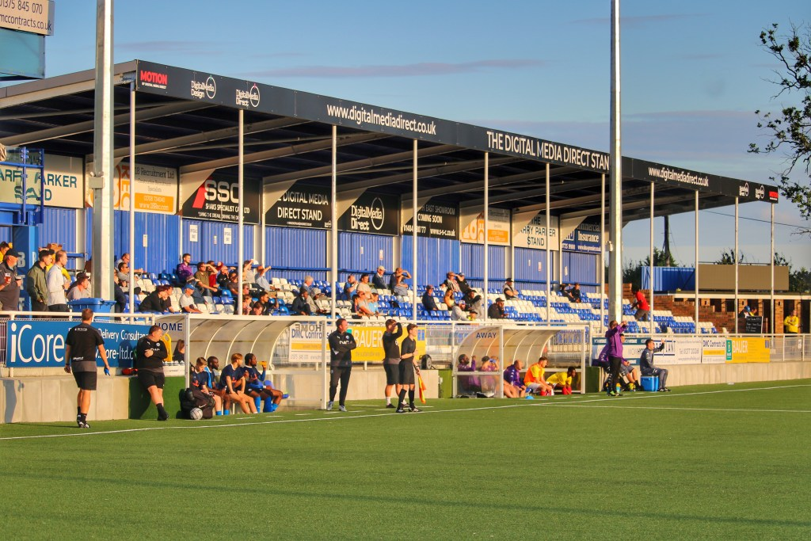
In the South it is just as tight with Welling United (30pts) and Billericay Town (30pts) currently propping up the table but with games in hand on Bath City (33pts), joined by Chelmsford City (31pts) and Tonbridge Angels (33pts).
Going up will be 8 teams - the 4 Step 3 winners and the 4 Steps 3 Play-off winners. As we stand today the four champions would be Worthing, Buxton, Met Police and Banbury United.
Step 3 to 4
Nine teams will be relegated from Step 3 to 4 at the end of the season. The two bottom placed teams in the four leagues plus the 3rd from bottom with the worst points per game record. It is nine rather than ten teams as the Southern League Central is only running with 21 clubs after the withdrawal at the start of the season of Abingdon Town.
At things stand at the moment, Kings Langley in the Southern Premier South would be the unlucky third from bottom side.
Going up with be the eight Step 4 Champions (currently Hastings United, Bracknell Town, Aveley, Liversedge, Warrington Rylands, Ilkeston Town, Bedford Town and Frome Town) plus the eight play-off winners. Whilst a couple of the leagues are relatively clear cut (Bracknell Town have already won the title, Hastings ten points clear), the others such as the Isthmian North are very close indeed.
Step 4 to 5
This is where it gets tricky. There are 16 Step 5 Divisions in the country. The 16 champions will be automatically promoted. The ten best second placed clubs based on a points per game average will also be automatically promoted.
The six second placed clubs that are not automatically promoted will each contest a play-off match against one of six teams from Step 4. There are 8 Step 4 Divisions. The 8 bottom clubs and the 8 second bottom clubs at Step 4 will be automatically relegated. The 2 third bottom clubs with the the highest points per game average will be reprieved but the remaining six third bottom clubs will contest the play-off matches mentioned above. The play-off matches will all take place on the grounds of the Step 4 clubs and the matches will be arranged on the best geographical fit decided by the Football Association.
The winners of each play-off match will play at Step 4 in 2022-23 and the losers will play at Step 5.
The bottom clubs in each of the 16 Step 5 Divisions will be automatically relegated to Step 6. The four second bottom clubs with the worst points per game average across the 16 divisions will also be relegated.
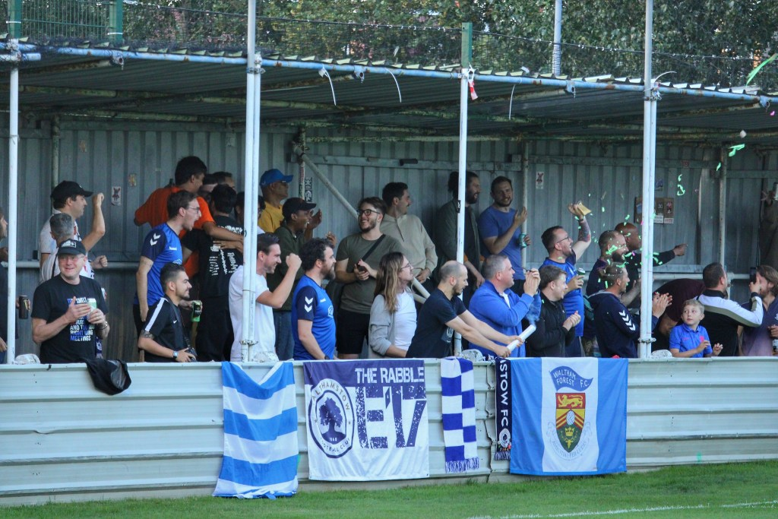
As we stand today, the following clubs could be promoted to the Isthmian League (at Step 4), taking into consideration the geographical boundaries of the leagues:
- Hanworth Villa (already crowned Combined Counties North Champions) and Southall
- Walton & Hersham and Beckenham Town (from Combined Counties South)
- Walthamstow (already crowned champions) and Stansted from the Essex Senior League
- New Salamis (Spartan South Midlands) who play at Haringey Borough
- Littlehampton Town and Saltdean United (Southern Combination)
- Chatham Town and Sheppey United (Southern Counties East - the latter has been promoted)
Some of the leagues are still very tight - in the Southern Combination for instance Newhaven are still in the mix, whilst the winners of the Eastern Counties League (Wroxham or Gorleston) could come into the Isthmian Leagues, as too may Lowestoft Town if they are relegated from the Southern League at Step 3.
Any further withdrawals from within the National League System will impact upon the situation outlined above.
Simple, right?

