AN UNHOLY TRINITY - BRITAIN'S BIGGEST CITY WITHOUT A PROFESSIONAL TEAM
A favourite question in trivia quizzes, the answer often beats even the best of us. But by some way, the answer is Wakefield and there’s little chance of them getting a professional side any time soon.
Of course, we all know the answer is Wakefield, right?
The cathedral city, with Leeds to the North, Barnsley to the South and Huddersfield on the western horizon has a population of nearly 330,000 based on the most recent census results but has never hosted a professional football side. This is Rugby League territory, with the city’s side, Wakefield Trinity having won the twice (the golden years of 1967-68) and five challenge cups. Their stadium, The 9,000 capacity Belle Vue has been their home since 1892 and for a period did host a football side.
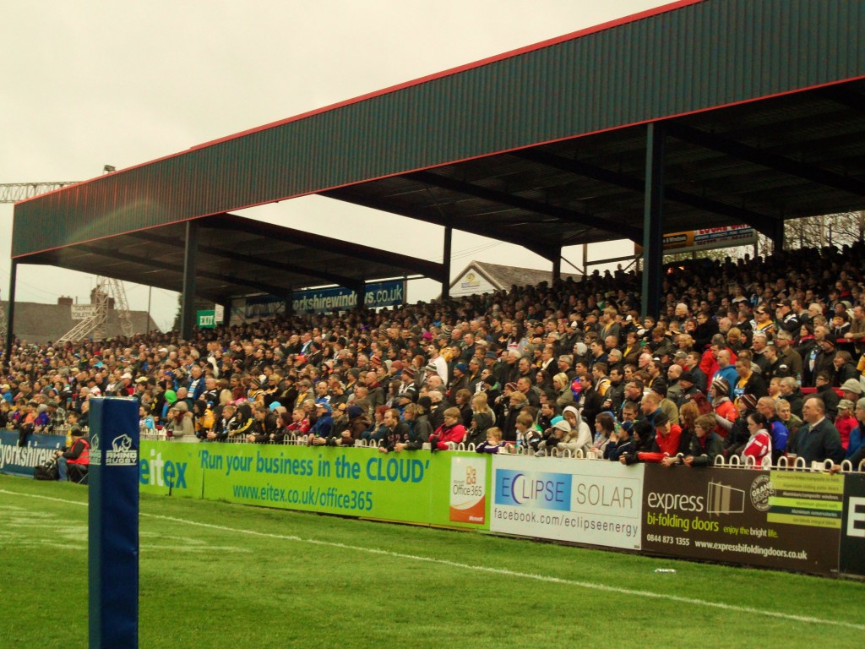
Whilst Frickley Athletic, today playing at Step 4 in the Northern Premier League (East) can claim to be within the metropolitan area, the city’s original side Wakefield & Emley FC existed from 2004 to 2014, having moved from the village of Emley where a team had played for over 100 years. Emley, for those who love a bit of trivia, is home to the Emley Moor Tower, the 4th tallest structure in the United Kingdom at 330m high.
The move was part of a massive investment in the city to try to bring professional football to the region. For those with good memories, you may recall that the club reached the third round of the FA Cup back in 1998 when they were still in the Unibond League. They drew West Ham United and travelled down to London, knowing that they were facing a Harry Redknapp side who were, quite frankly, a bit of a joke.
Unsurprisingly to the Hammers fans, the Non-League side more than held their own, equalising Frank Lampard's 4th minute opener just after half-time, only losing to a late John Hartson effort. The following season the club reached the Quarter Finals of the FA Trophy, still as a Step 3 side. Two seasons later they missed out on promotion to Step 1 despite reaching a mammoth 101 points, losing out to Stalybridge Celtic by a single point.
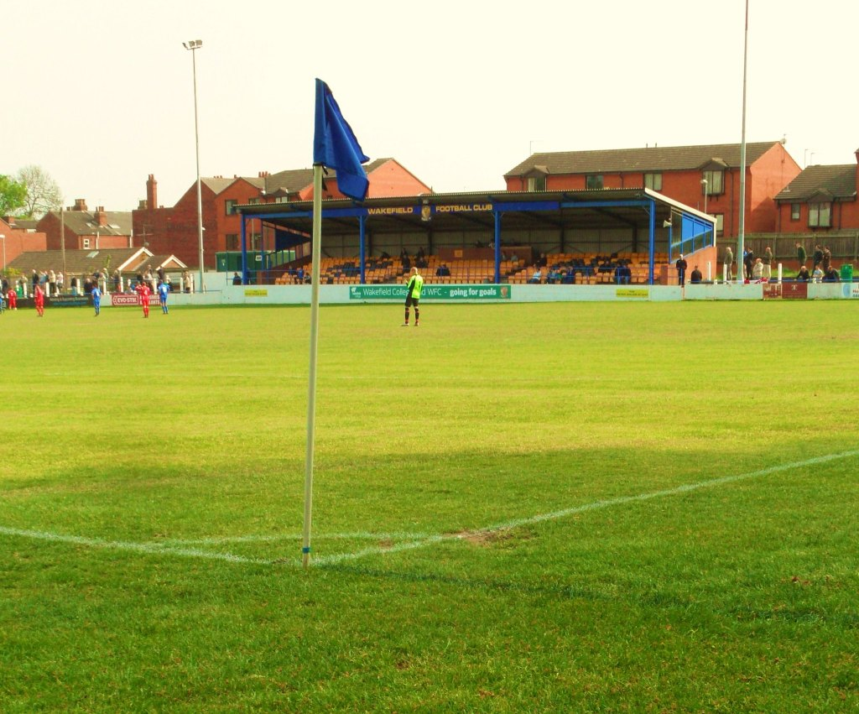
At the end of the 2005/06 season, Wakefield & Emley FC became just Wakefield FC and they found a ground in the city centre at College Grove, which was also the home of the Rugby Union side. But the club could never reclaim the glory years under the Emley name and at the end of the 2013-14 season, having finished bottom of the Northern Premier League Division One North, the club folded.
Emley reformed as AFC Emley the following season, moving back to their ground in the village and are today in the Northern Counties East Premier League (Step 5), having gained promotion during the summer as part of the FA's reshuffle. However, they are a long way away from their glory years of twenty years ago.
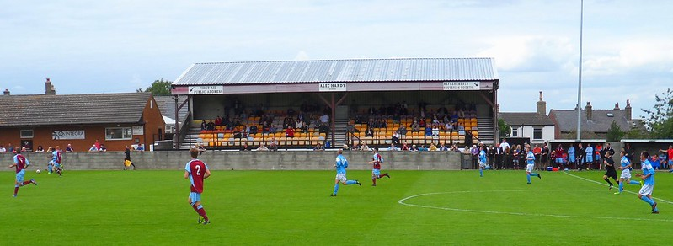
Despite some tentative discussions in the last few years, Wakefield remains football-less and so it is safe to continue to answer those trivia questions about the biggest UK city without a professional team for some time yet.

